CROSSOVER TECH TRIAL

Accident Management System

**Basic architecture design**

July 2015

## Common Architecture

## 

*Common system structure (arrows represents data flow)*

The entry point for users of system is **Dashboard Web Application**, hosted on IIS. This is presentation layer of solution. It can be assessed from internet and intranet, from different kind of devices. Dashboard Application provides API based on JSON REST services, which can be used by future mobile applications.

The central component of the system is **Enterprise** **Service Bus**. Service Bus works as centralized message exchange component. Most of solution services communicates not directly with each other, but throw Service Bus.

For each solution service Service Bus has own adapter and 2 endpoints (addresses) per each service method – for request and response of service.

The communication function of Service Bus is transportation messages between endpoints. Because all messages passing throw one component – It’s easy to react, route, transform and create new messages inside this component. So application business logic – is an orchestration of messages in the system.

**Communication service** is separate component, it uses Windows-based authentication. It’s embedded to the dashboard application like widget.

**Notification service** used to sending mass notification (voice, email, SMS) by current workflow’s contacts lists.

**Resource Providers Systems** is a third-party vendor’s and any company systems integrated to process resource requests, logistics and so on.

## Crisis management team

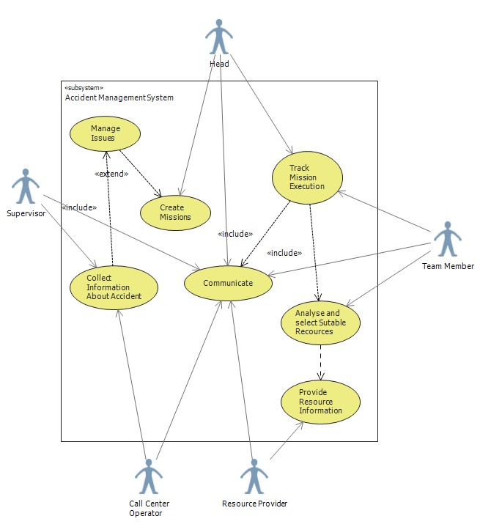

*Team Members Roles Use Case diagram*

* Head. Manage tasks, control all tasks execution, sets tasks priority, assign members to tasks, and so on.
* Member. Tracks assigned tasks execution. Select suitable resource from pool. Communicate with resource providers and supervisors.
* Supervisor. Monitor situation at the place. Clarifies accident information. Manage issues. Communicate with other team members.
* Call center operator. Collect information from witness’s appeals.

System can manage one or more teams. Each team can have own members with corresponding roles.

## Workflow conception

Workflow of crisis management consists of set of reactions on predefined actions. Actions and reactions triggered by receiving messages to corresponding adapters.

The main concepts, operated by workflow:

* **Issue**. This is a situation, which need to react to minimize accident effect. Issue has following categories: «Victim», «Destruction/Termination», and «Contamination/Infection», following types: «Accomplished», «Hazard/Risk» and text description. Set of issues can completely describe accident situation and observable risks. For example see table below:

|  |  |  |  |
| --- | --- | --- | --- |
| **ID** | **Description** | **Category** | **Type** |
| 1 | Ground floor of warehouse is on fire | Destruction | Accomplished |
| 2 | 2 containers with chemicals are damaged | Destruction | Accomplished |
| 3 | Chemical contamination of 20 acres around warehouse | Contamination | Hazard/Risk |
| 4 | Explosion of chemicals on the first floor | Destruction | Hazard/Risk |
| 5 | First and second floors of warehouse burned out | Destruction | Hazard/Risk |
| 6 | Injury or death of 3 operators blocked on the second floor | Victim | Hazard/Risk |
| 7 | Injury of witness | Victim | Accomplished |
| 8 | Death of one operator on the ground floor | Victim | Accomplished |

* **Mission**. This is an operation required to handle issue. Is assigned and tracked by responsible employee from crisis center. Each issue can have one or more missions to fix it. For example issue #5 needs quenching of fire mission, and issue #3 needs people evacuation mission.
* **Resource Category**. This is a group of resources, required to process one kind of Missions. Examples: Emergency medical treatment, Transportation, Hospitalization, Water provision, Warm clothes provision and so on.
* **Resource Providers Pool**. This is a set of Resource Providers, who can provide resources of same category.
* **Resource Provider**. Vendor, employee or volunteer who provide resource.
* **Resource Request**. Request of required resource to Resource Providers Pool .
* **Employee**. Internal member of crisis management team, company employee.

So, workflow structure of crisis management consists of next actions:

* Managing issue records which reflects current situation.
* Creating tasks, required to handle corresponding kind of issue.
* Creating resource requests required to execute corresponding kind of missions.
* Selecting suitable resource response from one or several providers.
* Track mission execution by assigned team member.

This workflow model is easy to understand, flexible and can handle most of crisis management processes.

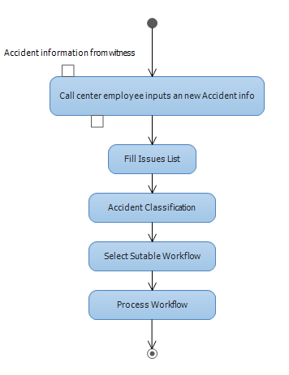

*Common Crisis/Accident workflow.*

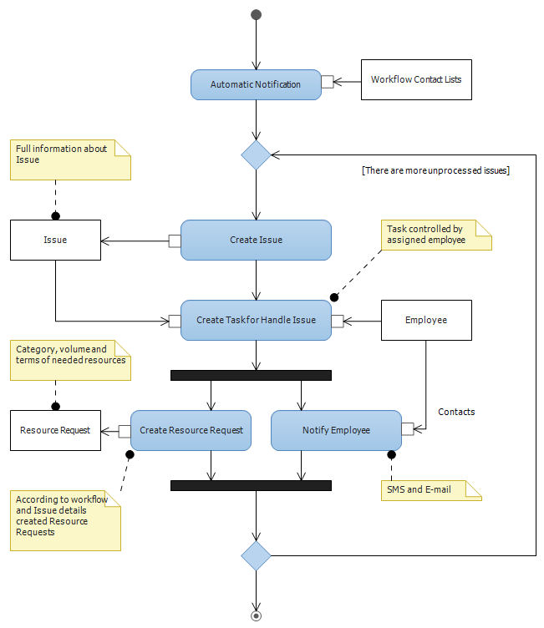

*Issue handle workflow.*

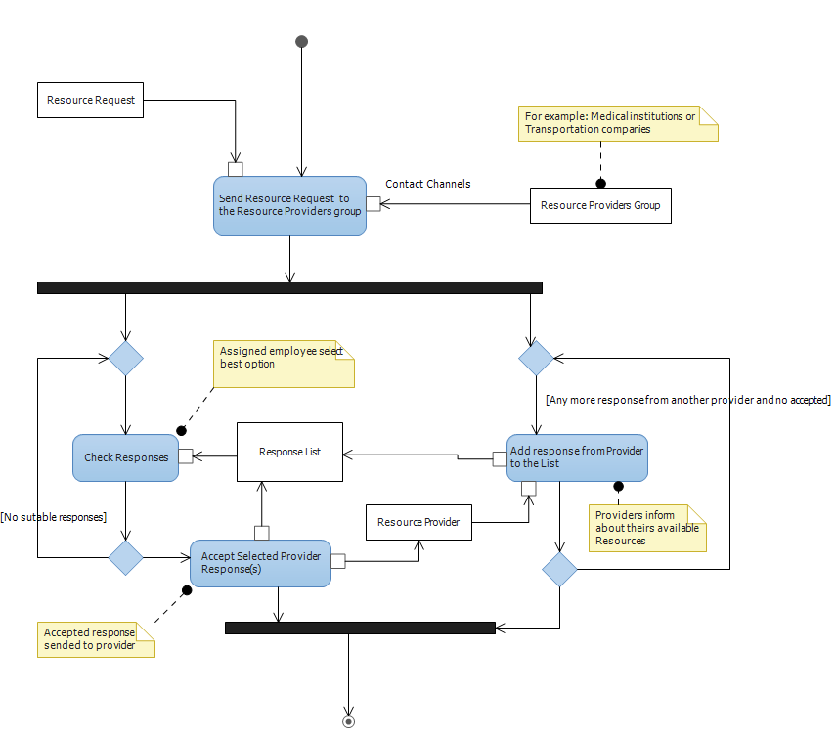

*Resource manage workflow.*

## Communication conception

Communication between team members in the system is carried out by next kind of instant messaging approaches:

1. Private messages User-to-User. The message window is always available on the Dashboard portal.
2. Conference virtual rooms. For one accident can be created one or more conference rooms. All conference messages available for room visitors. Each team can have own conference. For example Family Care center is one of crisis teams. This team works in own virtual room.
3. User can send e-mails to members of any teams.

In messages you can attach any data, which are references (links) to artifacts database items.

## Artifacts database

This component used to store any files, related to crisis management process. Files stored in hierarchical structure corresponded workflow. Each artifact have unique path, used for reference from communication messages. Path has readable structure. For example path Artifact://Fire20150701/Victims/photo2 reference to file IMG_2315.JPG.

Component consist of NoSQL database and web service for access it.

## Scalability and reliability

For realization this concepts suggested to use next approaches:

1. Servers virtualization
2. Database Clusters
3. Real-time Load Balancing

All solution can be hosted in cloud by IasS model.

## Security

All communications channels between client and server components, and between external integrated systems must be protected with SSL or VPN.